**Worksheet 6**

**Student Name: Ritika Rana UID:19BCA1126 Branch: BCA Section/Group: A/2**

**Semester: 6th Date of Performance:18/03/2022**

**Subject Name: MICROPROCESSOR AND INTERFACING LAB**

**Subject Code: CAP-356**

1. **Aim/Overview of the practical:**A **memory location 3040H consist of data 65H and 3041H consist of 24H. Write a program to subtract two 8-bit numbers without borrow and store the result at 3042H.**
2. **Task to be done:** Subtraction of two 8 bit numbersand show the result in specific location.

**3.Hardware Required:**8085 Microprocessor

**4. Program:**

LXI H,3040H;

MOV A, M;

INX H;

MOV B, M;

SUB B;

INX H;

MOV M, A;

HLT

**5. Observations:**

LXI The instruction loads 16-bit data in the register pair designated in the operand.

MOV This instruction will move the content.

INX Increment register pair by 1.

SUB This instruction will Subtracts the content of the accumulator with the content of the register B.

HLT This instruction will terminate the program.

**6. Calculations:**

Input: - 65H, 24H

Binary representation: -

65H – 0110 0101

24H – 0010 0100

Subtraction–0100 0001

Hexadecimal – 41H

**7. Output:**

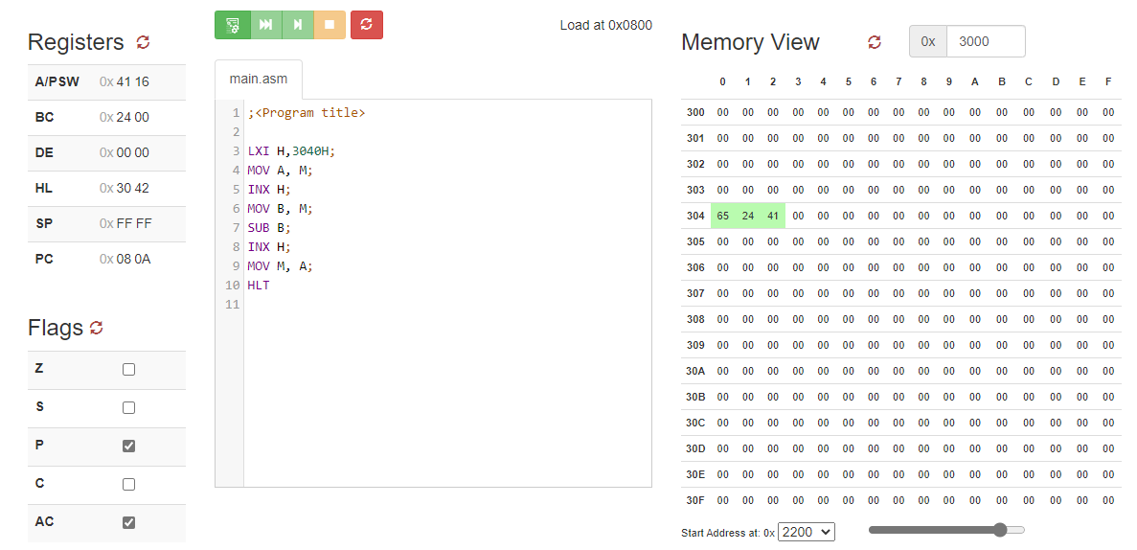

**9.Learning outcomes (What I have learnt):**

1. 8085 also sequences the instructions to be executed.
2. To perform **subtractTwo 8-bit Numbers and Show Result inspecific location.**
3. To perform subtraction of two 8-bit numbers without borrow on 8085 microprocessors.

**Evaluation Grid (To be created as per the SOP and Assessment guidelines by the faculty):**

|  |  |  |  |
| --- | --- | --- | --- |
| Sr. No. | Parameters | Marks Obtained | Maximum Marks |
| 1. |  |  |  |
| 2. |  |  |  |
| 3. |  |  |  |
|  |  |  |  |